ELGRA Medalist Life Sciences:
Dr. Enno Brinckmann
European Space Agency (retired)
Currently: Eschenweg 16, 26789 Leer, Germany
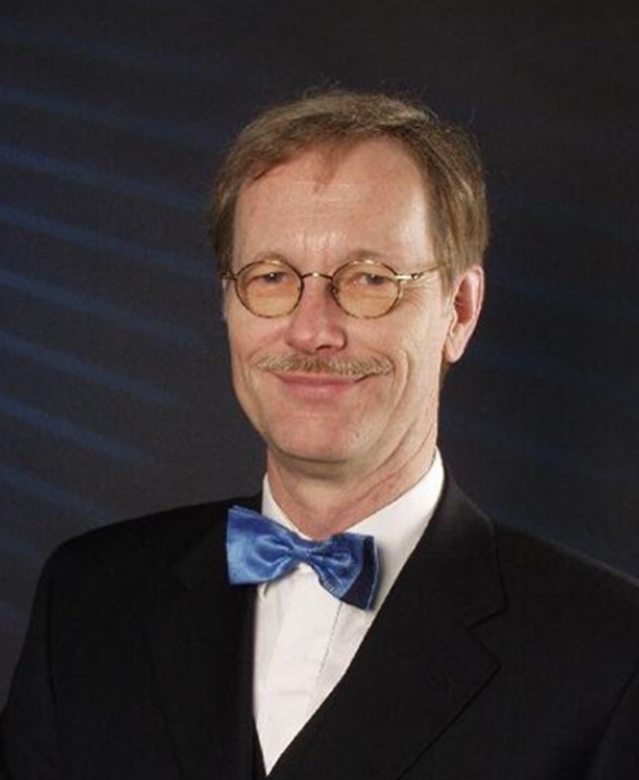
The German biologist (born 22.11.1946) got his scientific education at universities in Darmstadt and Tübingen. He got a diploma in biology 1971 and completed his studies 1973 with a dissertation about light induced oscillations of membrane potentials in higher plant cells.
He worked from 1975 until 1989 in the field of plant ecology at the University of Bayreuth as an academic lecturer. In addition to his administrative and lecturing duties for the department he supported several eco-physiologic field studies in the Namib-Desert, the results of which had been published 1992 in a book (von Willert, Eller, Werger, Brinckmann and Ihlenfeldt: "Life Strategies of Succulents in Deserts", Cambridge University Press).
In the lab he used the pressure probe to study water relations in single cells of higher plant leaves. 1989 he got a position as Senior Biologist at the European Space Agency (ESA) in Noordwijk, the Netherlands. Working as Project Scientist for the Biorack facility and Experiment Coordinator for Biolab, Dr. Brinckmann was involved in the accommodation, preparation and control of about 100 biological experiments in Spacelab, Spacehab and the International Space Station (ISS).
After the IML-2 mission in 1994, he received the Silver Snoopy Award by NASA astronaut Don Thomas. Besides 50 original papers (29 as coauthor) he published several short communications, posters and non-reviewed articles in scientific and popular journals. In addition, he gave invited lectures at universities in Germany, France, England, Italy, the Netherlands, USA and Sweden and edited 2007 the book “Biology in Space and Life on Earth” (Wiley-VCH). He retired from ESA in 2006 and lives now in Leer (Germany). From there he is supporting the University of Trondheim as an external advisor for plant space research questions.

