ELGRA Medalist Physical Sciences:
Prof. Dr. J. C. Legros
Université Libre de Bruxelles, Micro Gravity Research Center
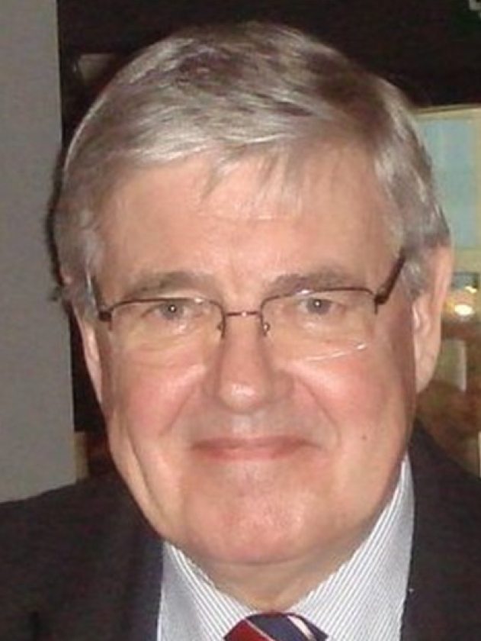
Jean Claude Legros (born 24.2.1942) is Emeritus Professor of the Université Libre de Bruxelles and during 20 years he held an administrative appointment as the director of the Microgravity Research Center (ULB).
He received his PhD in Sciences (supervised by Professor I.Prigogine) in 1971. His scientific interests are centered on coupling between the Soret effect and the Marangoni convection, especially on the influence of these temperature induced concentration fields on the onset of hydrodynamic instabilities in non-isothermal liquid solutions, on evaporation and on heat transfer. He has an outstanding track record at least in two of these three areas.
On top of his pedagogical activities in thermodynamics, since 1983, Professor Legros is managing research works in physics of fluids and of interfaces inside the Microgravity Research Centre which became under his supervision an innovative Centre which is at the forefront of experimental and theoretical researches related to experiments performed on earth orbit. By using experimental skills and physical intuition he has overcome the great difficulties which are obviously inherent in investigations of fluid properties under microgravity conditions. He obtained with his team excellent results on the role of surface tension forces in convective transport. He initiated and coordinated experiments on Spacelab (D1 and D2 missions, IML2, LMS), on Eureca 1, on Russian FOTON’s (12, M1, M2 and M3), and used extensively the MSG on ISS. These experiments were prepared by sounding rocket and parabolic flights (KC135, DC8, Caravelle, Airbus 300, Fouga Magister).
His efforts supported by Belspo and ESA result in a series of contributions consisting of more than 250 refereed publications and some of them are highly cited. Jean Claude Legros is also the coauthor of 4 books related to the convection in liquid phases and published in prestigious editing companies. He presented numerous scientific reports at international Congresses.
Besides academic works, Professor Legros was always interested by the applications. Using the tools and knowledge developed in MRC he founded with some staff members 2 companies: Lambda-X and EHP (Euro Heat Pipes SA). The first one is active in optical metrology; its partnership with Verhaert D&D (now Qinetiq) is very fruitful (see e.g.; FSL on ISS and FLUIDPAC on Foton platforms). The second was created 10 years ago through a venture with SABCA is now the European leader for the design and production of thermal control systems for satellites (e.g. for ATV). J.C. Legros is still a senior consultant in EHP.

