ELGRA Medallist Dr. Marianne Cogoli

Space Biology Group ETH Zürich, Switzerland (retired)
Zero-g LifeTec GmbH

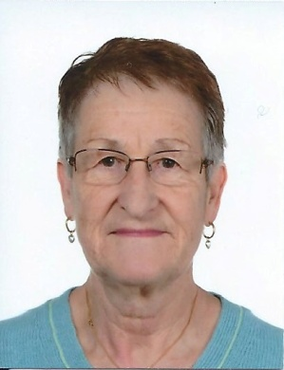

Marianne Cogoli (born 4.3.1943) got her Ph.D. in organic chemistry at the University of Zürich, Switzerland, in 1971. After 2 years of research assistance in the Department of Organic Chemistry at the University of Zürich, she attended a one-year Postgraduate Course in Experimental Medicine and Biology at the University of Zürich. From 1974-75 she was Visiting Scientist at the Weizmann Institute of Science (Department of Biochemistry), Rehovot, Israel. Back in Switzerland she worked for 6 years as Research Assistant in the Institute of Biochemistry, University of Zürich followed by 5 years in the laboratory of Medical Oncology, University-Hospital, Zürich where she gained experience in cell biology and immunology.
In January 1986 Marianne Cogoli joined the Space Biology Group at the Swiss Federal Institute of Technology (ETH Zürich) headed by her husband Augusto Cogoli. She was Investigator team member of 9 experiments performed on 5 different Spacelab /shuttle missions (Spacelab 1, Spacelab SLS-1, IML-1, IML-2 (coordinator and responsible for execution) and STS-107 and 5 experiments on Sounding Rockets (Maser 3, Maser 4, Maxus 1B and Maxus 2) which all were under here responsibility. Furthermore she was Principal Investigator for 1 experiment on Maser 9 and 1 flown in Kubik BIO#1 on ISS. For many experiments outlined above she was involved in the development, manufacture and testing of the space qualified hardware. The major scientific interest and experience of Marianne Cogoli in Space Biology/Biotechnology are related to the adaptation of the immune system and mammalian cells to changes of the gravitational environment. Due to her great experience in space biology, she was consultant to ESA and to several major aerospace companies. She was manager of two scientific studies on Biolab for the Columbus Attached Laboratory and the Columbus Free Flying Laboratory of ESA and of the science team for the Biolab studies. In 2000 ESA appointed one of the European User Support Centers to the ETH Zürich. The center, called BIOTESC (Biotechnology space Support Center), is a support center for Biolab and responsible center for Kubik and was headed until 2007 by Marianne Cogoli. Marianne Cogoli is author and co-author of 39 publications in peer reviewed journals and 27 in proceedings, 25 resp 26 in the field of space biology / biotechnology and other space related activities. In 2004 Marianne Cogoli founded together with her husband an ETH spin-off company - Zero-g LifeTec GmbH. Today she is still executive director of this company.
From 1995-2005 Marianne Cogoli was member of the ELGRA Management Committee, 1997-1999 as Vice-President and 1999-2003 as President. 2001-2008 she was Swiss delegate to the Programme Advisory Committee for Esrange Andoya special projects and from 2004-2007 member of the Swiss commission on space activities.

